Create SSIS package using lookup transformation.  
1. Reading all data from excel and load into destination table without any   
  
modification  .

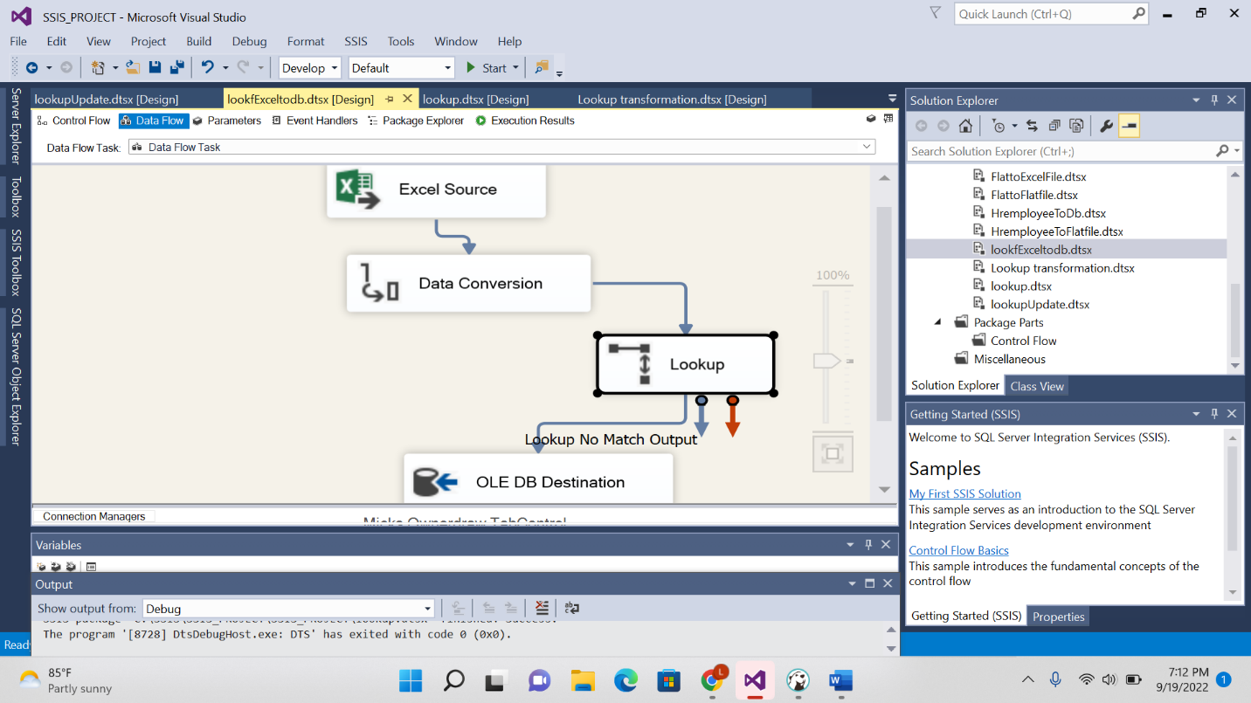

2.Read all data from excel/flat file and load  into destination table using any modification.

